**EXPERIMENT 8**

**REGRESSION METHODS**

**1. Linear Regression Method**

Ques 1:

|  |  |  |  |  |  |
| --- | --- | --- | --- | --- | --- |
| x | 1 | 2 | 3 | 4 | 5 |
| y | 2 | 4 | 5 | 4 | 5 |

Ques 2:

|  |  |  |  |  |  |
| --- | --- | --- | --- | --- | --- |
| x | 0 | 25 | 50 | 75 | 100 |
| y | 157.076 | 156.2419 | 154.7758 | 154.2522 | 153.2005 |

**CODE**

***METHOD 1***

clc

clear all

%y=a+b*x

n=input('enter the number of data values: ');

x=input('enter data for x: ');

y=input('enter data for y: ');

a=0;b=0;c=0;d=0;

for i=1:n

a=a+x(i);

b=b+y(i);

c=c+x(i)*y(i);

d=d+x(i)*x(i);

end

A=[n,a;a,d]

C=[b;c]

B=inv(A)*C

slope=B(2,1)

intercept=B(1,1)

**OUTPUT**

**ANS 1**

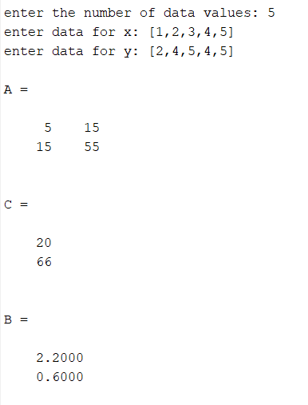

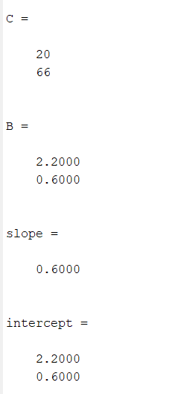

**ANS 2**

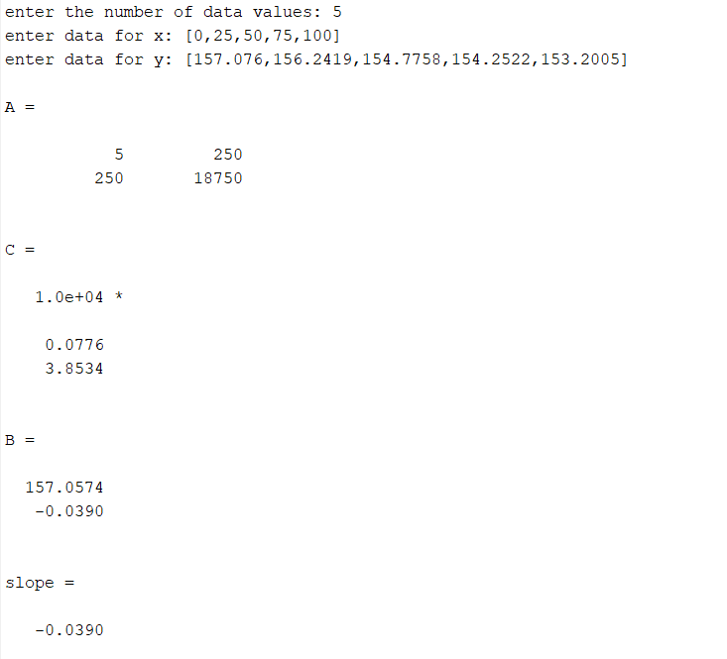

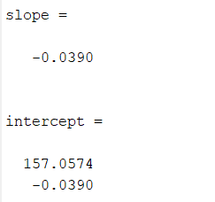

**METHOD 2**

clc

clear all

%y=C+B*x

n=input('enter the number of data values: ');

x=input('enter data for x: ');

y=input('enter data for y: ');

a=0;b=0;c=0;B_num=0;B_den=0;

for i=1:n

a=a+x(i);

b=b+y(i);

end

x_bar=a/n;

y_bar=b/n;

for j=1:n

B_num=B_num+(x(j)-x_bar)*(y(j)-y_bar);

B_den=B_den+((x(j)-x_bar))^2;

end

B=B_num/B_den;

for k=1:n

A(k)=(y(k)-B*x(k));

end

for l=1:n

c=A(l)+c;

end

c_net=c/n;

slope=B

intercept=c_net

**OUTPUT**

**ANS 1**

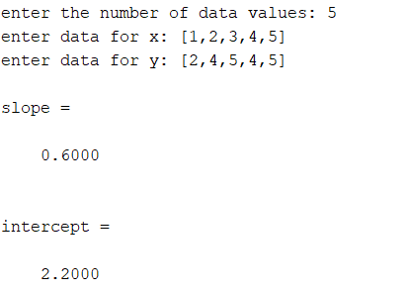

**ANS 2**

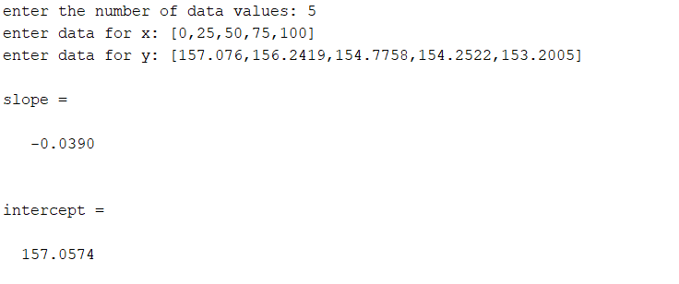

**2.Quadratic Regression Method**

Ques 1:

|  |  |  |  |  |  |
| --- | --- | --- | --- | --- | --- |
| x | 3 | 4 | 5 | 6 | 7 |
| y | 2.5 | 3.2 | 3.8 | 6.5 | 11.5 |

Ques 2:

|  |  |  |  |  |  |  |  |
| --- | --- | --- | --- | --- | --- | --- | --- |
| x | 80 | 40 | -40 | -120 | -200 | -280 | -340 |
| y | 6.47 | 6.24 | 5.72 | 5.09 | 4.3 | 3.33 | 2.45 |

**CODE**

clc

clear all

%y=a+b*x+c*x^2;

n=input('enter the number of data values: ');

x=input('enter data for x: ');

y=input('enter data for y: ');

a=0;b=0;c=0;d=0;e=0;f=0;g=0;

for i=1:n

a=a+x(i);

b=b+x(i)^2;

c=c+x(i)^3;

d=d+x(i)^4;

e=e+y(i);

f=f+x(i)*y(i);

g=g+(x(i)^2)*y(i);

end

A=[n,a,b;a,b,c;b,c,d]

C=[e;f;g]

B=inv(A)*C

slope_double=B(3,1)

slope_single=B(2,1)

intercept=B(1,1)

**OUTPUT**

**ANS 1**

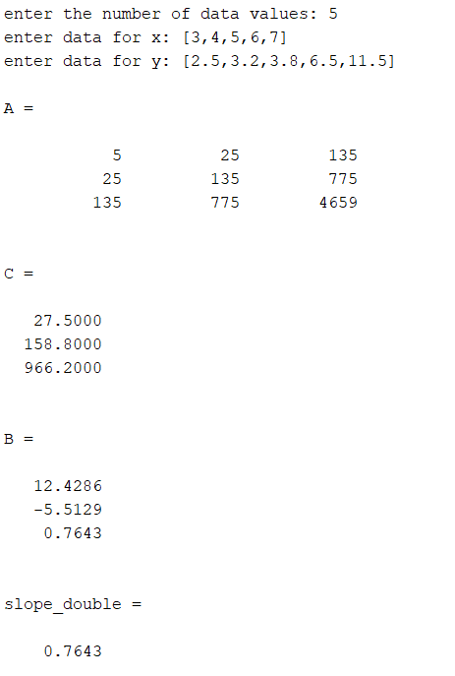

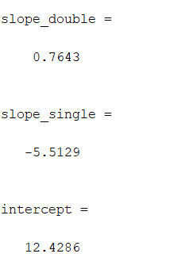

**ANS 2**

